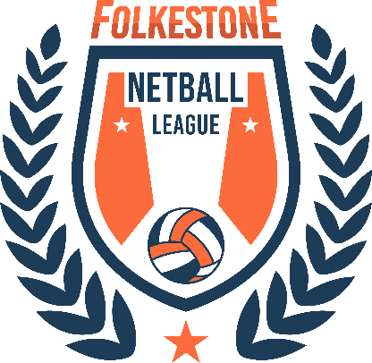
Code of Conduct for Players
Our Codes of Conduct require the highest standards of conduct from everyone involved in netball to ensure that their behaviour and actions meet the values and standards expected at all times.
Everyone must conduct themselves in an honest, fair, impartial and transparent manner.
We ask that you will respect:
- The rules, regulations and requirements of the Sport, including, but not limited to, any Competitions in which you participate either directly or indirectly
- The rights, dignity and worth of all people involved in netball, regardless of any protected characteristic (age, disability, gender reassignment, marriage and civil partnership, pregnancy and maternity, race, religion or belief, sex, and sexual orientation)
- The game of netball and the individual’s reputation and not take any action or make inappropriate comments, including on Social Media, about a fellow participant, coach, official, volunteer or member of club staff that will bring the Sport or those associated with delivering the Sport into disrepute
Netball is based on Teamwork, therefore I will:
- Not abuse or misuse any relationship of trust held by me in my team, be that my playing team, Club, County, Regional or England Netball
- Be on time, dressed appropriately and ready to give my full attention to the coaches and volunteers.
- Recognise that individuals bring different qualities and attributes but “together we will excel”.
- Welcome new members, players, coaches, volunteers, and connected participation and cooperate with all players, coaches and volunteers
I Recognise individuals participate in Netball to achieve and have fun, therefore I will:
- Recognise the achievements of others and applaud their successes
- Help fellow players achieve their potential through encouragement and recognising their successes.
- Never use inappropriate or abusive language, bully, harass, discriminate or use physical violence.
- Never engage in discriminatory abuse or anti-social behaviour.
- Not impinge on others enjoyment of the Sport or my performance by consuming alcoholic drinks,
- Display modesty in victory and graciousness in defeat; be sporting – whether I win or lose; always acknowledge the other team and the umpires at the end of the game with a hand shake or three cheers.
- Never argue with an official or participant during a game and listen to and cooperate with officials’ decisions
- Control my temper; I understand that verbal, emotional and physical abuse of officials, coaches, spectators or participants, or deliberately distracting or provoking a participant, coach or official is not acceptable or permitted behaviour in netball
- Enjoy the game and ensure other can also enjoy it.
I will endeavour to abide by this code of conduct and promote it to others.

