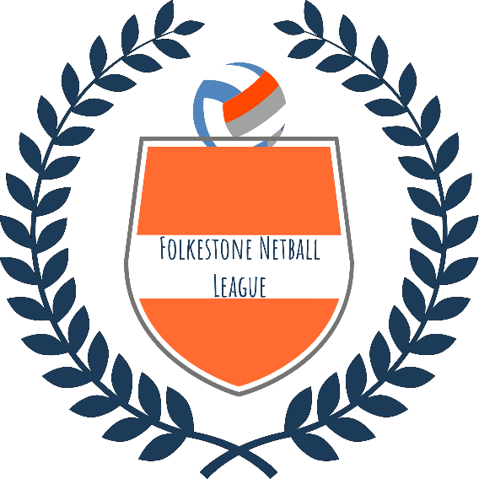

Dear Potential Sponsor,

I am writing to you on behalf of Folkestone Netball League to enquire whether you would like to help us on our mission to raise funds to make some much needed improvements to our netball courts.

We are a Folkestone based League and we play all our matches, training and regular tournaments and fun days at the Three Hill Sports Park. Three Hills is a large facility that attracts approximately 5000 visitors each week, and is host to many sports clubs including Netball, Cricket, Football, Hockey and Running to name but a few. Our Netball League alone has over 300 members and supporters.

Unfortunately, the netball courts are currently in urgent need of resurfacing to make them safe to play on in all weathers. We are passionate about our sport and keeping our players safe and fit and therefore we need to ensure that the courts are slip resistant and suitable to play on throughout the winter months – this year we have had to cancel many matches due to the conditions.

To help us do this, we would like to invite you to advertise your company on a banner/hoarding such as the example overleaf, and become a sponsor of Folkestone Netball League. The sponsorship we are asking for is £500 for the year, in addition to the cost of the banner which you are welcome to arrange with the supplier direct. We would be looking to run the advertising period from April – April, but can of course make exceptions if you need time to prepare your advertisement. In return, as well as displaying your banner for a year, we will add your logo/company details to our website, on our ‘Sponsorship’ page.

As I have mentioned, Three Hills Sports Park is very popular amongst local clubs and holds many events which attract visitors from far and wide so there is no doubt that your adverts will be seen by many! The location of the netball courts means your advertisement will be seen by all visitors to the 3G pitch, approximately 2000 each week!

If you would like to discuss this advertising opportunity, please contact – enter your own name and contact details here. We can arrange for you to meet with a committee member and show you the netball courts if you wish.

We look forward to working in partnership with you.

Kind Regards,

Your own name

On behalf of Folkestone Netball League

\**Example advertising hoarding:*

*