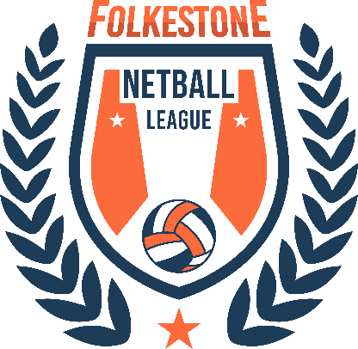

Parent release form for media recording
I, the undersigned, do hereby grant or deny permission for Folkestone Netball League to use images of my child (name)____________________________, as marked by my selection(s) below. Such use includes the display, distribution, publication, transmission, or otherwise use of photographs, images, and/or video taken of my child for use in materials that include, but may not be limited to, printed materials such as brochures and newsletters, videos, and digital images such as those on the Folkestone Netball League website.

- Deny permission to use my child’s image

- Grant permission to use my child’s image in the following ways (mark all that apply).
- Limited usage: I want my child’s image used within the Folkestone Netball League setting only (not in the larger community).

- Limited usage: I want my child’s image to be used for educational materials only (not marketing). This could be either within Folkestone Netball League or in the larger community. One example of this could be video’s in parent education classes.

- Limited usage: I want my child’s image used on printed material only (no digital or video use).

- Unrestricted usage: I give unrestricted permission for my child’s image to be used in print, video and digital media. I agree that these images may be used by Folkestone Netball League for a variety of purposes and that these images may be used without further notifying me. I do understand that the child’s last name will not be used in conjunction with any video or digital images.
Parent/Guardian signature: ________________________________ Date:_______________________
Please make a copy of this form for your own records and return the original to:
Hannah Palmer at this email address: folkestonenetball@gmail.com

